SIS: AI-Powered L1 Support

Document Control 1
1.1 Document History 1
1.2 Review Panel 2
1.3 Approvals 2
1.4 Supporting Documents 2
Project Details 3
Introduction 3
Description of the Problem 3
Solution Requirements 4
Solution Overview 4
Components 4
Capabilities 5
Architecture 6
Deliverables 7
Conclusion 8

Document Control

1.1 Document History
Modified By | Modified On | Comments/Notes | Version
Vijay .R | 18/02/2025 | Initial Draft | 1.0

1.2 Review Panel
Name | Role
GenAI Organizing Team | Coordinators

1.3 Approvals
Version | Approval Date | Approver Details
1

1.4 Supporting Documents
Document | Location | Owner

Project Details

Project Title | SIS: AI-Powered L1 Support
Project Sponsor | InfoServices
Approval Body
Approved Budget
Project Lead
Team

Introduction
SIS (Smart IT Support) is an AI-powered Level 1 (L1) IT support system designed to automate and streamline IT issue resolution. It integrates AI-driven ticket classification, log monitoring, auto-troubleshooting, and a chatbot to assist users with common technical problems. The system reduces manual intervention, enhances operational efficiency, and ensures faster resolution times.

Description of the Problem
Traditional IT support faces challenges like slow response times, manual ticket classification, and inefficiencies in handling repetitive requests. Support teams struggle with high workloads, delayed escalations, and ineffective log monitoring, leading to unresolved issues and security risks. Manual processes in email-based ticketing systems further slow down resolutions, making IT support less efficient and more prone to human errors.

Solution Requirements
The solution must automate IT support processes using AI to classify tickets, monitor system logs, and provide proactive troubleshooting. It should integrate a chatbot for handling common issues, an AI-powered ticketing system for efficient categorization, and a streamlined approval process for software installations. Additionally, the system must ensure seamless user interactions, quick response times, and secure data handling while reducing dependency on manual intervention.

Solution Overview
The AI-powered L1 Support Engineer application automates routine IT support tasks, including troubleshooting common issues like printer malfunctions and slow internet. It leverages AI for ticket classification, log monitoring, and self-healing mechanisms, ensuring faster issue resolution. With proactive system health predictions and voice-based IT support, the solution enhances operational efficiency by providing real-time support and escalation to higher-level engineers when needed.

Components
- Streamlit: For creating the user interface.
- openai: Python client for interacting with OpenAI models.
- pandas: Data manipulation and analysis library.
- psutil: Retrieves system and process information.
- shutil: High-level file operations (copy, move, delete).
- st-aggrid: Streamlit component for interactive data tables.
- tiktoken: Tokenizer for processing text with OpenAI models.
- pypdf2: Manipulates and processes PDF files.
- scikit-learn: Machine learning library for data analysis and modeling.
- matplotlib: Library for creating static and interactive visualizations.
- OpenAI API: To generate detailed feedback and analysis using GPT models.

Component/Layer | Tool | Remarks
Platform

Capabilities
The solution will provide the following key capabilities:
• AI-Powered Ticket Classification: Automatically categorizes and prioritizes support tickets for faster resolution.
• Intelligent Chatbot: Provides AI-driven assistance to resolve issues quickly and efficiently.
• Log Monitoring & Anomaly Detection: Detects unusual behavior in system logs in real-time for proactive issue management.
• Auto-Troubleshooting & Service Restart: Identifies faults and automatically restarts malfunctioning services to ensure system stability.
• Admin Ticket Management: Enables admins to track, update, and resolve IT support tickets effectively.
• System Information Dashboard: Displays real-time system metrics, such as CPU, RAM, Disk usage, and last shutdown details for monitoring.
• Application Installer with Admin Approval: Manages secure application installations with required admin approval.
• Proactive System Health Predictions: Uses AI to predict potential system issues and prevent failures before they occur.
• About Company: Allows users to read and query company information extracted from a PDF document.

Architecture
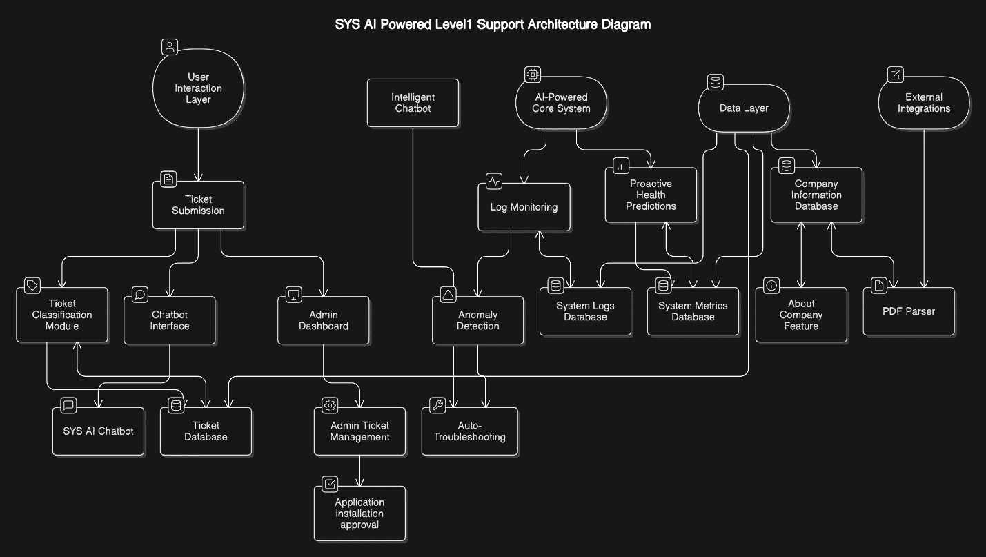
The SYS AI-Powered Level 1 Support Architecture Diagram outlines the structure and components of an AI-driven support system. Here's a brief explanation:
- User Interaction Layer:
  - Users interact with the system through Ticket Submission, Chatbot Interface, and Admin Dashboard.
- AI-Powered Core System:
  - The core system includes:
    - Ticket Classification Module: Categorizes and prioritizes tickets.
    - Intelligent Chatbot: Provides AI-driven assistance.
    - Log Monitoring: Detects anomalies in system logs.
    - Predictive Health Predictions: Uses AI to predict system issues.
    - Auto-Troubleshooting: Automatically resolves faults.
- Data Layer:
  - Stores and manages data in:
    - System Logs Database: For log monitoring.
    - Ticket Database: For support tickets.
    - System Metrics Database: For real-time system metrics.
    - Corporate Information Database: For company-related data.

- External Integrations:
  - Includes PDF Parser for extracting company information and other integrations for seamless functionality.
- Admin & Monitoring:
  - Admins use Admin Ticket Management to track and resolve tickets and Application Installation Approval for secure installations.

Deliverables
• I-Powered Ticket Classification:
- Automatically categorize and prioritize incoming tickets based on the issue type.
• Intelligent Chatbot:
- An AI-driven assistant to provide quick issue resolution, guiding users through common troubleshooting steps.
• Log Monitoring & Anomaly Detection:
- Real-time detection of unusual system behavior or potential issues, triggering alerts for the admin.
• Auto-Troubleshooting & Service Restart:
- Identifies faulty services and automatically restarts them to ensure system stability.
• Admin Ticket Management:
- Admin interface to track, update, and resolve IT support tickets efficiently.
• System Information Dashboard:
- Displays real-time system information like CPU, RAM, disk usage, and details of the last system shutdown.

• Application Installer with Admin Approval:
- A secure application installation process, requiring admin approval before installation, with status updates to prevent reinstallation.
• Proactive System Health Predictions:
- AI-powered predictive analytics to foresee potential system failures and recommend preventive actions.
• About Company:
- A feature allowing users to ask specific questions about the company. The system uses AI to provide answers based on company details stored in PDFs or other documents.

Conclusion
This project successfully developed an AI-powered IT support system that automates ticket classification, system monitoring, troubleshooting, and application installation, among other tasks. The system provides valuable insights into system health and offers predictive maintenance to prevent failures before they happen.
With the integration of AI and automation, IT support teams can significantly enhance their efficiency, minimize downtime, and provide a seamless user experience. Future work could include expanding the system's capabilities and improving the AI algorithms for even better performance.

